

Multimodal Biometric Authentication System for Enhanced Cyber Security

Submitted by: Soh Yan Zhang

Matriculation Number: U2222443J

Supervisor: A/P Mohammed Yakoob Siyal

Examiner: A/P Chen Lihui

Final Report Draft

School of Electrical & Electronic Engineering
Abstract

Acknowledgements

I would like to express my gratitude towards my supervisor A/P Mohammed Yakoob Siyal for their support and assistance throughout this entire project. I would like to thank my family and friends for their support throughout my academic years. Lastly, I would like to express my gratitude towards Prof Chen Lihui for dedicating their time and effort to evaluate my project.

Introduction

Over the years, the rapid digitalisation of services has caused cybersecurity threats to grow at an unprecedented rate, posing huge risks to not only individuals, but also organisations and governments worldwide. Password-based authentication methods, which remain as the most common form of verification, are becoming increasingly more vulnerable to a wide range of attacks such as phishing, brute-force, and social engineering. Moreover, the need to remember complex passwords often leads users to adopt weak or reused credentials, further compounding security risks.[1] Reports have consistently shown that password related breaches remain among the most common causes of data leaks, accounting for billions of compromised credentials annually.[2] As digital infrastructure become more integrated into our daily lives, the limitations of single-factor authentication highlights the need for stronger and more reliable solutions. In order to address these weaknesses, biometric authentication emerged in recent years as a promising alternative due to its reliance on unique behavioral traits such as fingerprints, facial features or palm patterns. Compared to conventional passwords, these unique features are inherently tied to the user, making it significantly harder for attackers to replicate or steal.[3]

However, unimodal biometric systems that rely only on a single trait are still susceptible to attacks such as spoofing, environmental influences or higher error rates. A fingerprint scanner may struggle with low quality impressions due to dirt or sensor malfunctions, while facial recognition can be affected by surrounding lighting or the use of accessories like glasses. [4] These limitations can be overcome by introducing and integrating different biometric authentication methods. This makes it harder for attackers as multiple biometric traits have to be compromised, emphasizing the need for a multimodal system for a stronger, more reliable authentication method.

This study aims to design and implement a multimodal biometric authentication system that integrates different biometrics features such as fingerprint, face and palm recognition. Multiple models and techniques will be explored in this study. Fingerprint recognition will employ both Minutiae Matching Algorithm and CNN-based fingerprint models while facial recognition will leverage algorithms such as Circular Gaussian Filter, Face Pattern Byte, supported by traditional methods like Eigenfaces for robustness under varied conditions. Lastly, palm recognition will adopt established feature extraction methods such as SIFT and CNN-based palm models. In order to unify these modalities, Weighted Score Fusion will be used to assign weightage to each biometric trait and machine learning classifiers for decision making will be used. By combining different biometric features, this study hopes to address the shortcomings of unimodal systems and password attacks by improving recognition accuracy, minimizing both false positives and negatives, and resist attackers’ spoofing attempts. In addition, the applicability of multimodal biometric authentication systems can extend to sectors requiring high-security standards such banking, healthcare and governmental systems, contributing to the ongoing efforts in cybersecurity research to safeguard sensitive information and advancement of authentication frameworks.

Chapter 2 Literature Review

2.1.1 Biometric Authentication

Biometric authentication is a security mechanism that verifies an individual’s identity based on unique physiological and behavioural characteristics. These traits are inherently linked to each person and are difficult to replicate, making biometric systems highly reliable for identity verification. Such systems are widely deployed across various applications, ranging from personal devices to enterprise systems such as banking platforms.
Biometrics systems can be broadly classified into two categories: unimodal and multimodal systems. Unimodal systems only rely on a single biometric trait, which is commonly implemented in modern smartphones. However, these systems may be vulnerable to spoofing, noise or data limitations. In contrast, multimodal systems combine multiple biometric traits to enhance accuracy, robustness and security. By implementing more than one characteristic, multimodal systems significantly reduces the likelihood of false acceptance and improves overall system reliability.

2.1.2 Types of Biometric Traits

Biometric traits are generally categories into two main groups:
- Physiological/Biological Characteristics
These are physical attributes derived from the human body, such as fingerprints, facial features, and palmprints. These traits are highly distinctive and remain relatively stable over time, making them suitable for high security applications.
- Behavioural Characteristics
These are normally traits based on an individual’s behaviour, such as voice patterns, signature dynamics. Behavioral biometrics are particularly useful for continuous or passive authentication as they can operate in the background without explicit user interaction.
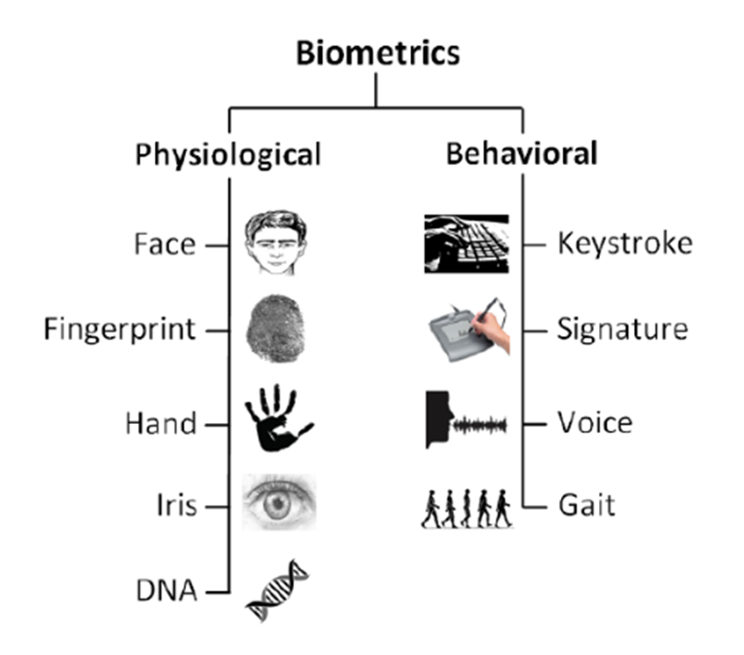

Although there are multiple biometric traits that exist, not all of them are suitable for practical deployment. There are other factors such as cost, system complexity and environmental conditions that limit the adoption of certain modalities. Therefore, this project will mainly focus on 3 commonly used biometric traits: fingerprint, face and palm and these modalities will be selected for multimodal implementation.

2.2 Facial Recognition

Facial recognition is a widely used biometric authentication technique that identifies or verifies individuals based on their facial features captured through images or videos. These systems typically acquire facial data using two-dimensional or three-dimensional imaging devices and compare the extracted features against stored templates in a database and compare the extracted features against stored templates in a database. Due to its contactless and non-intrusive nature, facial recognition is highly convenient and user-friendly, making it suitable for applications such as identity verification

Although facial recognition may be less accurate than fingerprint-based systems, it is often preferred in practical applications due to its ease of use and minimal user interaction requirements.

2.1.2 Fingerprint Recognition

Fingerprint recognition is one of the earliest and most widely adopted biometric authentication techniques. It verifies an individual’s identity by comparing fingerprint patterns, comprising unique ridges and valleys against previously stored templates. The distinctiveness, permanence, and ease of acquisition of fingerprints make this modality highly reliable for identity verification. As a result. Fingerprint recognition is extensively used in application such as law enforcement, financial systems and our day-to-day mobile authentication.

Fingerprint recognition systems are know for their high accuracy and cost-effectiveness, as they require relatively simple hardware and infrastructure compared to other biometric technologies. This makes them suitable for large-scale and everyday employment

2.1.3 Palm Recognition
Palm recognition is a biometric authentication method that identifies individuals based on analysing the unique patterns present on the surface of the human palm. These patterns include principal lines, wrinkles, ridges and texture features which together form a distinctive representation for each individual. Due to palm having a larger surface area compared to fingerprints, palm print recognition can capture both global and local features, enhancing its reliability and robustness.
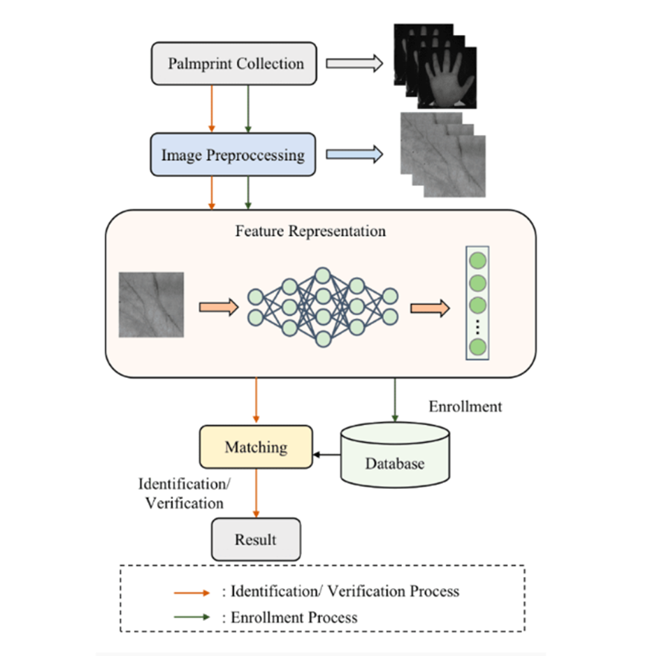

2.1.4 Iris Recognition

Iris recognition is a highly accurate and non-contact biometric authentication techniques that identifies individuals by analysing the unique texture patterns of the iris. These patterns are highly distinctive and stable over time. Not only that, between the left and right eyes of the same individual, differences can be observed. Due to this properties, iris recognition is widely regarded as one of the most reliable biometric modalities for high security applications such as border control.
The system typically uses near-infrared(NIR) imaging to capture detailed iris patterns that are not visible to the naked eye. This enables precise feature extraction while minimising interference from lighting conditions. Despite its high accuracy, iris recognition is less commonly deployed due to its higher cost and requirement for specialised hardware and user cooperation.

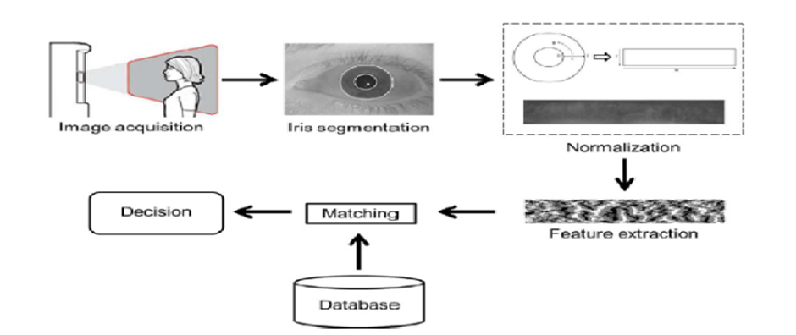

2.1.5 Voice and Speech Recognition (Behavioral)

Voice recognition, also known as speech-based biometric authentication, is a natural and convenient method of identifying individuals by analysing the unique acoustic characteristics of their speech. These characteristics include vocal tract shape, pitch, frequency and speaking patterns which collectively provide distinctive features for identity verification

Voice recognition has gained widespread adoption with the advancement of artificial intelligence (AI) and applications such as virtual assistants like Apple Siri, and smart home systems. Its hands-free and non-intrusive nature makes it highly user-friendly and suitable for remote authentication scenarios. However, its performance can be affected by environmental factors such as background noise, and changes in speaker condition such as illness or emotional state. These limitations can reduce accuracy as compared to more stable physiological biometrics

2.2.1 Evaluation of Biometric Traits

To determine the most suitable biometric modalities for integrations for the different biometric traits, this portion of the report will evaluate the five biometric methods being facial recognition, fingerprint recognition, palm recognition, iris recognition and speech recognition. The evaluation will be based on four key criteria being accuracy, ease of use, replicability and cost. These factors will be essential in assessing both the security performance and practical feasibility of each method.

2.2.1 Accuracy of Biometric System

Accuracy is one of the most important factors in evaluating biometric authentication systems, as it directly impacts the systems’ ability to correctly verify legitimate users while rejecting imposters. It is commonly measured using metrics such as False Acceptance Rate, False Rejection Rate and overall recognition rate

Biometric systems do not achieve perfect accuracy in real-world conditions, as their performance is influenced by several factors including environmental conditions, data quality and user variability.
- Facial recognition: Accuracy is highly dependent on external factors such as lighting conditions, camera quality . While deep learning techniques have significantly improved robustness, accuracy rate may still decline in unconstrained environment
- Fingerprint recognition: Generally offers high accuracy due to uniqueness of minutiae patterns. However, its performance can degrade when fingerprints are affected by dirt,dryness or physical damage
- Palm recognition: Offers high accuracy by analysing both global features like principal lines and wrinkles and local features such as texture and minutiae. Compared to fingerprints, palm prints contain a larger surface area, allowing for richer feature extraction and improved robustness
- Iris recognition: Offers the highest level of accuracy due to the highly detailed and stable nature of iris patterns. Moreover, it is less affected by factors such as ageing or other external conditions, especially when near-infrared imaging is used
- Voice or Speech recognition: Tends to have lower accuracy due to it being more sensitive to background noise, and changes in a user’s voice be caused by health issues or emotional condition can worsen the accuracy

Overall, iris recognition demonstrates the highest accuracy, followed by palm recognition, then fingerprint recognition, while facial recognition and speech recognition are more variable due to operating conditions.

2.2.2 Ease of Use (Usability)

Ease of use of authentication modals refers to how convenient and intuitive a biometric system is for users in everyday scenarios. This includes factors such as interaction simplicity, speed of authentication, and user comfort. Compared to traditional password systems, biometric authentication systems eliminate the need to remember complex passwords, allowing users to have superior user experience. Different biometric systems have significantly different level of ease of use.

- Facial recognition: It offers the highest level of usability as it is contactless and requires minimal effort from users. Facial authentication can occur passively by simply facing a camera, making it highly suitable for seamless user experiences.
- Fingerprint recognition: Simple and fast, however it requires physical contact with a sensor. Dirty or damaged fingers may reduce its ease of use, hence introducing hygiene concerns and dependency on finger condition
- Palm recognition: The system can be implemented in both contact-based and contactless forms. While it is generally user-friendly, it requires proper hand positioning and alignment, which may slightly reduce convenience compared to other biometric recognition
- Iris recognition: It has the lowest usability as it requires precise eye alignment and user cooperation, which may serve as an inconvenience for some users.
- Voice or Speech recognition: Speech recognition is also highly user-friendly, enabling hands-free interaction and natural communication. However, its usability may decrease in noisy or public environments
In summary, facial and speech recognition provides the highest usability, while iris and palm recognition are less practical for frequent, everyday use.

2.2.3 Replicability of System

Even though biometric authentication methods are more secure than traditional password-based systems, they are still prone to vulnerabilities such as spoofing or forgery. Replicability of a system refers to the extent to which a biometric trait can be forged, imitated, or spoofed, and is crucial factor in determining the overall security of a biometric authentication system. A robust system should be resistant to both direct replication, which is artificial biometric samples and presentation attacks such as photos or recordings. In practice, the security of biometric methods is also influenced by effectiveness of liveness detection mechanisms, which attempt to distinguish real human traits from fabricated ones.

- Facial recognition: Can be more vulnerable to spoofing attacks, as facial feature can be replicated using photographs, videos, masks, and now deepfake technologies. Although more advanced systems can employ liveness detection, sophisticated attacks may still bypass these safeguards
- Fingerprint recognition: This recognition exhibits relatively lose replicability due to the uniqueness of minutiae patterns. Nevertheless, it is still susceptible to spoofing using artificial fingerprints made from materials such as silicone or gelatine.
- Palm recognition: It provides moderate to strong resistance to spoofing by using a combination of principal lines, wrinkles, and texture features across a larger surface area. The richness of features increases the difficulty of replication and increases the difficulty of replication compared to simpler modalities. However, as palm prints relies on surface-level characteristics, it may still be vulnerable to high-resolution image-based attacks or artificial replicas if liveness detection is not implemented
- Iris recognition: Iris recognition demonstrates the strongest resistance to replication due to its highly complex and fine-grained internal texture patterns. These patterns are extremely difficult to reproduce accurately, and most systems incorporate additional liveness detection such as pupil changing size in response to light, further enhancing security
- Voice or Speech recognition: It is the most vulnerable modality, as it can be easily compromised using recorded audio or synthetic voice generation. While countermeasures such as voice liveness detection and anti-spoofing algorithms exist, high quality recordings or AI-generated voices continue to pose significant challenges
In a nutshell, biometric methods based on internal or complex biological structures such as iris offer the highest resistance to replication. In contrast, surface-level or behavioural biometrics such as facial and speech requires an additional security mechanism to mitigate spoofing risks. Palm print and fingerprint recognition provides a balanced level of security, especially when combined with liveness detection techniques.

2.2.4 Cost

Cost of biometric systems is a critical factor that impacts the feasibility, scalability and adoption of biometric authentication systems. It encompasses several components, including hardware acquisition, algorithm development, system integration, maintenance, and user training. The cost-performance trade off determines whether a biometric systems is suitable for large-scale deployment or limited to high-security applications.

- Facial recognition: System is relatively affordable, as iit can operate using standard RGB cameras. However, more advanced implementations that requires depth sensing or infrared imaging for improved accuracy and liveness detection may increases system costs
- Fingerprint recognition. It is one of the most cost-effective biometric solutions due to its technological maturity and widespread adoption. Fingerprint sensors are inexpensive, compact and easily integrated into consumer devices such as smartphones and access control systems
- Palm recognition: This system incurs moderate cost, depending on whether the system is contact-based or contactless. While it does not require specialised near-infrared hardware like palm vein recognition, it still requires larger imaging areas and more complex preprocessing and feature extraction, leading to moderate implementation and computational costs
- Iris recognition: One of the most expensive modality due to its reliance on high-precision near-infrared imaging systems and advanced processing algorithms. Additionally, strict requirements for user positioning and system calibration further increase deployment and maintenance costs
- Voice or Speech recognition: It has the lowest hardware cost, requiring only a basic microphone. However, its overall cost may increase due to the need for sophisticated algorithms for noise reduction, feature extraction, and model training, especially in real-world environments.

Hence, facial, fingerprint and speech recognition are more economically viable for large scale and consumer level applications due to their lower hardware requirements. In contrast, iris recognition is typically reserved for high security environments where cost is less of a constraint. Last but not least, Palm print recognition offers a middle ground, balancing improved feature richness with moderate cost, but it may still face adoption challenges compared to more established and cost-effective methods.

2.2.5 Conclusion

Biometric Methods | Characteristics
 | Accuracy | Usability | Replicability | Cost
Facial | M | H | M | L
Fingerprint | M | M | M | M
Palm | H | M | L | M
Iris | H | L | L | H
Voice | L | H | M | L

Based on the comparative analysis of biometric methods in terms of accuracy, usability, replicability and cost, each modality demonstrates distinct strengths and limitations, highlighting the trade-offs involved in selecting suitable authentication techniques.
Firstly, facial recognition provides a strong balance between usability and cost, offering high convenience due to its contactless nature. However, its moderate accuracy and vulnerability to spoofing reduces its reliability in high-security situations without additional safeguards

Next, fingerprint recognition presents a well-established and balanced solution, with moderate performance across all criteria. Its maturity, reliability, and widespread adoption make it a practical choice, although it may be affected by environmental and physiological conditions such as dirty or damaged fingers.
Palm print recognition stands out with high accuracy and low replicability, indicating strong security performance. Its ability to capture a larger set of features enhances robustness compared to fingerprint recognition. However, its moderate usability and cost may limit its widespread adoption in consumer-level applications.
Iris recognition offers the highest level of accuracy and security due to its extremely low replicability. Nevertheless, its low usability and high implementation cost make it less suitable for everyday applications, confining its use primarily to high-security environments.

Voice recognition, while highly convenient and cost-effective, demonstrates lower accuracy and moderate vulnerability to spoofing. Its performance is significantly affected by environmental noise and variability in speech, making it less reliable as a standalone authentication method.

In conclusion, no single biometric method is optimal across all criteria. Modalities such as iris and palm print recognition excel in security and accuracy but are limited by cost and usability, while facial and voice recognition prioritise convenience at the expense of security. Fingerprint recognition provides a balanced compromise between these factors. Therefore, combining multiple biometric modalities in a multimodal authentication system is a more effective approach, as it leverages the strengths of each method while mitigating their individual weaknesses.

Chapter 3 Biometric Recognition Techniques

This chapter introduces three biometric technologies: facial recognition, fingerprint recognition, and palm print recognition, along with the techniques employed in each modality. These methods form the core components of the proposed multimodal biometric authentication system.

Facial recognition relies on computer vision and deep learning techniques to verify identity through processes such as face detection, alignment, and feature extraction. In this study, facial recognition is implemented using ResNet50-based embedding models, which generate highly discriminative feature vectors for accurate identity matching under varying conditions such as lighting and pose.

Fingerprint recognition will be based on the analysis of unique ridge patterns present in fingerprint images. The system combines traditional and deep learning approaches by utilising Minutiae Matching algorithms to capture key ridge features such as endings and bifurcations, alongside CNN-based embeddings models to extract more robust and discriminative representations. This hybrid approach enhances both accuracy and resilience against variations in fingerprint quality.

Palm print recognition leverages the rich set of features present on the surface of the palm, including principal lines, wrinkles, and texture patterns. In this study, palm print recognition is implemented using CNN-based embeddings combined with Gabor filter-based feature extraction to capture both global structural and local texture information. This combination improves feature representation and matching performance

Later in Chapter 4, this project will transition into the practical implementation of these techniques through the development of a real-time multimodal biometric authentication system. The system integrates all three modalities and applies feature extraction, matching and fusion techniques to achieve a more accurate and reliable identity verification

3.1 Overview of Facial Recognition

3.1.1 CNN
Convolutional Neural Networks (CNNs) are a class of deep learning models that have become fundamental in modern computer vision tasks, including image classification, object detention, and biometric recognition. As a specialised type of feedforward neural network, CNNs are designed to automatically learn hierarchical feature representations from input data, making them particularly effective for image-based applications

A typical CNN architecture consists of a sequence of convolutional layers, pooling layers, and fully connected layers, which work together to progressively extract and refine features from raw input images. This hierarchical structure enables the network to capture both low level features such as edge and textures and high-level features such as shapes and semantic patterns, improving the model’s ability to generalise across different data variations.

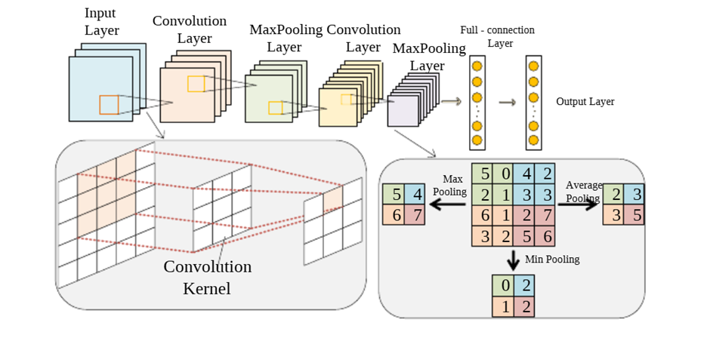
The convolutional layer is the core component of a CNN, responsible for extracting local features from the input. It applies a set of learnable filters known as kernels that slide across input images to compute feature maps. Mathematically, the convolution operation can be expressed as:
Through this operation, CNNs are able to detect meaningful patterns such as edges,corners and textures. Unlike traditional methods that rely on handcrafted features, CNNs automatically learn these features during training, making them more adaptable and robust

Pooling layers are used to reduce the spatial dimensions of feature maps, thereby lowering computational complexity and preventing overfitting. By summarising local regions, pooling also helps the model become more invariant to small distortions in the input

Common types of pooling include:
- Max Pooling: where it selects the maximum value within a region, preserving the most prominent features
- Average Pooling: Computes the average value within a region, resulting in smoother feature representations
Pooling later plays an important role in retaining essential information while reducing redundant details, improving both efficiency and generalisation.

After feature extraction through convolution and pooling , the resulting feature maps are flattened and passed into fully connected layers. These layers perform high-level reasoning and classification by learning relationships between extracted features.

3.1.2 ResNet

Residual Network (ResNet) is a deep convolutional neural network architecture introduced by KaiMing He and his team in 2015. It was proposed to address key challenges in training very deep neural networks, particularly the vanishing gradient problem and the degradation problem, where increasing network depth leads to reduced performance.

In conventional deep neural networks, stacking more layers theoretically improves the model’s ability to learn complex representations. However, in practice, deeper networks often experience performance saturation or degradationp[]. This issue arises not due to overfitting but because deeper architectures are more difficult to optimise, causing gradients to either vanish or explode during backpropagation

ResNet overcomes these limitations through the concept of residual learning, which introduces residual blocks which skip connections that allow information to bypass one or more layers. Instead of directly learning a mapping function H(x), the network learns a residual function F(x), defined as: F(x)= H(x) -x

Thus the original function can be reformulated as : H(x)= F(x) + x

This formulation enables the network to focus on learning the residual difference between the input and the desired output, which is often easier to optimize. The input x is directly added to the output of the residual function via a shortcut connection, ensuring that important information is preserved throughout the network.

3.2 Overview of Fingerprint Recognition

3.2.1 Minutiae-Based Fingerprint Matching

Early approaches to fingerprint recognition relied heavily on minutiae-based methods, which remain one of the most fundamental and widely adopted techniques in biometric systems. Minutiae refer to distinctive local ridge features, primarily ridge endings and bifurcations, that uniquely characterise a fingerprint. These features are extracted from fingerprint images and used as the basis for matching and identification

Minutiae-based approaches leverage the inherent uniqueness and permanence of fingerprint patterns to achieve reliable identification. Numerous studies have contributed to the development of robust minutiae extraction and matching algorithms, establishing them as a cornerstone in fingerprint recognition systems. These methods typically represent fingerprints as sets of minutiae points, characterized by their location, orientation and relational structure, enabling effective comparison between fingerprint samples.

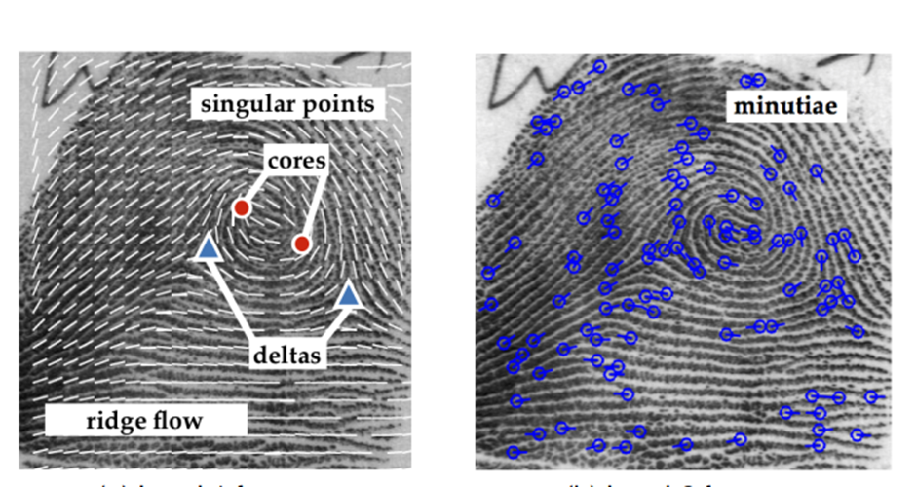

3.2.1 CNN-based Fingerprint Embedding

With the advancement of deep learning, Convolutional Neural Networks (CNNs) have been increasingly applied to fingerprint recognition to overcome the limitations of traditional methods. Unlike handcrafted feature extraction, CNNs automatically learn hierarchical and discriminative features directly from fingerprint images

Similar to CNN-based facial recognition, in CNN-based fingerprint recognition, the input fingerprint image is passed through multiple convolutional layers to extract both low-level features and high-level representations. The network then generates a compact embedding vector, which uniquely represents the fingerprint.

3.2.3 Hybrid Approach: Minutiae + CNN
In this project, a hybrid fingerprint recognition approach will be adopted, combining minutiae-based matching with CNN-based embeddings. This approach leverages the strengths of both techniques:
- Minutiae matching will provide strong interpretability and reliability based on well-established fingerprint features
- CNN embeddings will enhance the robustness by capturing complex patterns and variations that may not be represented by minutiae alone.
By integrating both methods, the system achieves improved accuracy and resilience against variations such as noise distortion and partial fingerprints.

3.3 Overview of Palm Recognition

3.3.1 Gabor-Based Feature Extraction

Gabor-based methods are among the most widely used traditional approaches in palm print recognition. Gabor filters are effective in capturing texture and orientation information, as they model the response of the human visual system and provide optimal localisation in both spatial and frequency domains.
During the feature extraction stage, the plan image is first processed to extract the region of interest (ROI) which typically corresponds to the central area of the palm containing the most discriminative features. The ROI is then normalised to ensure consistency across different samples.
Gabor filters are subsequently applied to the ROI at different scales and orientations, generating multiple features maps that highlight important texture patterns such as lines and ridges. These responses can be further encoded using techniques such as histogram-based descriptors or binary feature representations to form a compact feature vector.
Gabor-based methods are widely used due to their strong ability to capture local texture features. However, the performance may be affected by variations such as illumination changes, rotations and noise as they rely on handcrafted feature extraction.

3.3.1 CNN-based Palm Print Embedding

Convolutional Neural Networks (CNNs) have also seen an increase in adoption for palm print recognition to overcome limitation of traditional methods. CNNs are capable of automatically learning hierarchical and discriminative features directly from palm images

Similar to other CNN-based biometric recognition, the input image is passed through multiple convolutional layers to extract both low-level features (e.g., edges and textures) and high-level representations (e.g., line structures and global patterns). The network then produces a compact embedding vector that uniquely represents the palm print.

3.3.3 Hybrid Approach: CNN + Gabor Features
In this study, a hybrid palm print recognition approach is adopted, combining Gabor-based feature extraction with CNN-based embeddings. This approach leverages the strengths of both techniques:
- Gabor features effectively capture local texture and orientation information from palm images
- CNN embeddings provide robust and high-level feature representations that are resilient to variations and noise.
By integrating both methods, the system benefits from both domain-specific feature extraction and data-driven learning, resulting in improved accuracy and robustness. This hybrid approach is particularly effective in handling challenges such as illumination changes, misalignment, and partial palm images.

Chapter 4 Implementation of Authentication Systems

4.1 Project Overview

4.1.1 Dataset

Since there is no shared-identity multimodal dataset, we created pseudo-identities by pairing one face identity, one fingerprint identity, and one palm identity under a common synthetic subject ID (e.g. s001). This supports software integration and fusion experiments, but does not represent true cross-modal identity correspondence.We created pseudo-identities by pairing one face identity from VGGFace2, one fingerprint identity from SOCOFing, and one palm identity from the selected palm dataset under a shared synthetic subject ID for multimodal system integration and fusion experiments.

4.2 Facial Authentication System
4.3 FingerprintAuthentication System

4.4 Palm Authentication System
Chapter 5 Project Results

Chapter Conclusion and Future Works

Challenges Faced

Reflection

REFERENCES
[1] J. Bonneau, C. Herley, P. C. Van Oorschot, and F. Stajano, “The quest to replace passwords: A framework for comparative evaluation of web authentication schemes,” in Proc. IEEE Symp. Security and Privacy, San Francisco, CA, USA, 2012, pp. 553–567.
[2] Verizon, 2023 Data Breach Investigations Report (DBIR), Verizon Business, 2023. [Online]. Available: https://www.verizon.com/business/resources/reports/dbir/
[3] A. K. Jain, A. Ross, and S. Prabhakar, “An introduction to biometric recognition,” IEEE Trans. Circuits Syst. Video Technol., vol. 14, no. 1, pp. 4–20, 2004, doi: 10.1109/TCSVT.2003.818349.
[4] S. M. Arman, T. Yang, S. Shahed, A. A. Mazroa, A. Attiah, and L. Mohaisen, “A comprehensive survey for privacy-preserving biometrics: Recent approaches, challenges, and future directions,” J. Inf. Secur. Appl., vol. 83, 2024, Art. no. 103786, doi: 10.32604/cmc.2024.047870.
[5] S. Narwal and D. Kaur, “Comparison between minutiae-based and pattern-based algorithm of fingerprint image,” Int. J. Inf. Eng. Electron. Bus., vol. 8, no. 2, pp. 9–15, 2016.
[6] M. M. Islam, A. A. M. Muzahid, and K. Andersson, “Fast and accurate face recognition based on image compression,” in Proc. SPIE 10443, Applications of Digital Image Processing XL, 2017, doi: 10.1117/12.2263541.
[8] A. Rattani and R. Derakhshani, “Unimodal and multimodal biometric sensing systems: A review,” IEEE Sensors J., vol. 17, no. 3, pp. 589–602, 2017. [Online]. Available: https://ieeexplore.ieee.org/document/7580649

